PRESS RELEASE

COMMUNICATIONS AND MEDIA TEAM OF THE 43RD ASEAN SUMMIT 2023

No.11/SP/TKM-ASEAN2023/ENG/8/2023

Familiarising Indonesian Youth with ASEAN by Gemuruh Musik ASEAN Concert

Jakarta, 30 August 2023 - The youth of Jakarta and Greater Jakarta packed Anjungan Sarinah, the open space on the front of Indonesia’s first shopping center, in the late afternoon to watch the Gemuruh Musik ASEAN 2023 music concert, which took place on Wednesday (30/8/2023) evening.

The concert was organized by the Director General of Public Information and Communications of the Ministry of Communications and Informatics (MCI) in the series of promotional events for the organisation of the 43rd ASEAN Summit.

Performing at the concert were Indonesian popular singers Dikta Wicaksono and Idgitaf. Apart from that, a Filipino dance group gave a stunning performance of Tinikling Dance.

Based on observation by the Communications and Media Team of the 43rd ASEAN Summit 2023 in the Sarinah area, a good turnout of young people have packed the Sarinah Pavilion space since 4pm even though the concert started at 6pm Western Indonesian Time.

Lydia Rahmayeni (20), a young Ciledug resident, admitted that she wanted to watch the performance of her singer idol, Idgitaf. Lydia and her seven colleagues came to the Sarinah area by MRT. "I really wanted to come earlier so I could get a seat on the bridge steps, but it turned out it was already full. There’s even a queue, look, it’s only 5.30 now,”," said Lydia.

However, Lydia was not discouraged by the long queue. She was willing to join the queue for watching her idol's performance. "My spirit’s up. I'm an Idgitaf fan. So I’ve to watch the concert," said Lydia enthusiastically.

At the event, MCI Director General of Public Information and Communications Usman Kansong said that the 2023 Gemuruh Musik ASEAN concert was held to familiarise the young people of Indonesia with ASEAN. It is expected that young people will have the understanding about the organisation of the 43rd ASEAN Summit, which will take place in Jakarta on 5—7 September 2023. "To disseminate ASEAN-related information in a fun way, the young people way," said Usman.

On the same occasion, the Ministry of Foreign Affairs’ Director for ASEAN Political and Security Cooperation, Rolliansyah Soemirat, said we should be proud because this year, Indonesia became chairman of ASEAN. "You should be proud because with Indonesia as chairman, we play a role in shaping future agendas and plans for what can be done in the future to grow together and prosper together," he said.

For your information, Sarinah is a State-Owned Enterprise (BUMN), initiated by the Proclaimer and First President of the Republic of Indonesia, Ir Soekarno, to accommodate domestic product trade activities and encourage the growth of the Indonesian economy.

This big mission was realized by constructing the Sarinah Building on Jl. M.H. Thamrin, Jakarta. The inauguration of the Sarinah Building on 15 August 1966, also marked its presence as the first shopping center in Indonesia.

Carrying out President Soekarno's mandate that Sarinah must become a center for trade and promotion of domestically produced goods, primarily agricultural and industrial products, to this day, Sarinah continues to uphold its commitment to support the progress of products from small, medium, and cooperative businesses. (Ismadi Amrin/Alex/TR/PR)

***

For more information, please contact:
Director General of Public Information and Communications of the Ministry of Communications and Informatics – Usman Kansong (0816785320).

Get more information at http://asean2023.id, https://infopublik.id/kategori/asean-2023, and https://indonesia.go.id/kategori/ragam-asean-2023

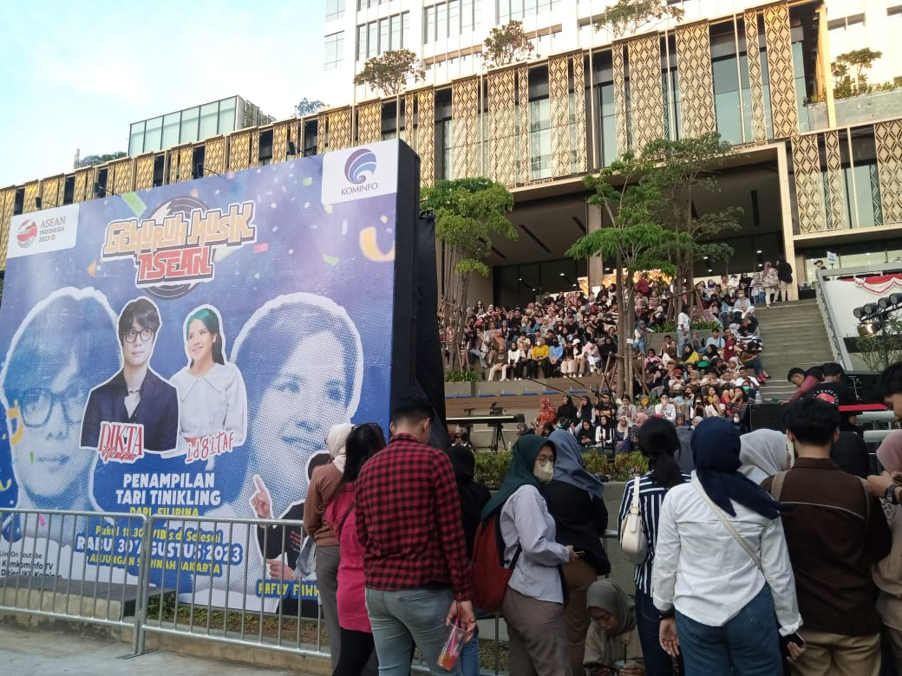

Young people from Jakarta and its surroundings pack the Anjungan Sarinah, Central Jakarta, in the late afternoon to watch the Gemuruh Musik ASEAN 2023 concert, Wednesday (30/8/2023) evening. (Ismadi/Elvira/InfoPublik)

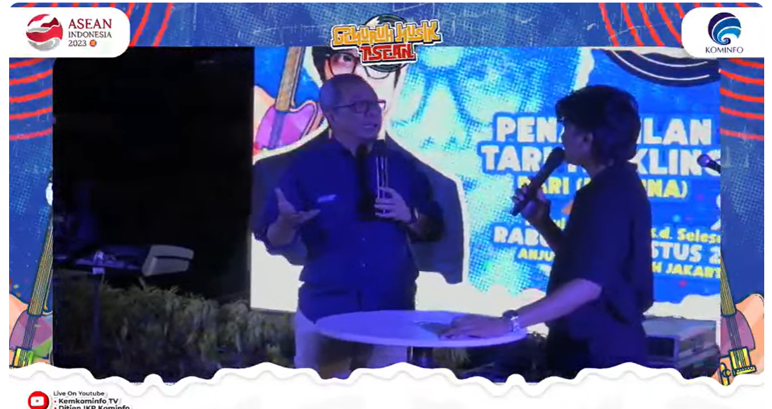

MCI Director General of Public Information and CommunciationsUsman Kansong said that the 2023 Gemuruh Musik ASEAN concert was held to familiarise ASEAN to young people, Wednesday (30/8/2023) (Screenshot of MCI’s DJIKP Youtube channel broadcast/Elvira)

